**Documentation for Catpedia Project**

1. **Website Map**

Contact Us

Vote on Cats

Care for Cats

Breeds Page

Home(Refresh)

Landing Page(index.html)

Thank you(for subscription) Page

Contact Form(on click)

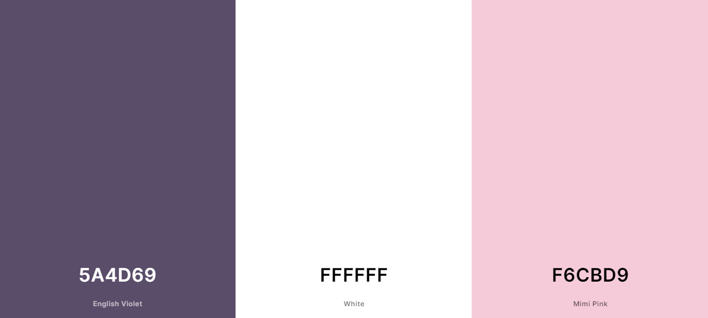**2. Style Guide**

**NAV**

Background-color:#f6cbd9d8

color: #5a4d69;

font-family: "Maven Pro", sans-serif;

**Nav logo:**

font-size: 25px;

font-weight:800

**Nav links:**

font-size: 16px; 

**Header:**

color: white;

font-family: "Maven Pro", sans-serif;

**Search Bar & Subscribe Bar:**

background-color: white;

border-radius: 50rem;

border: solid 2px #f6cbd9;

text-color:#5a4d69;

border: solid 2px #f6cbd9;

**Button:** font-size: 14px;   
 border-radius: 50rem;   
 background-color: #5a4d69;   
 color: white;   
 font-family: “Secular One”, sans-serif;



**Main Content:**

title-color: #5a4d69;

color: black;

line-height: 30px;

text-align: justify;

font-family: Verdana,sans-serif;

**Image - Care:**   
 object-fit: cover;   
 border-radius: 20px;   
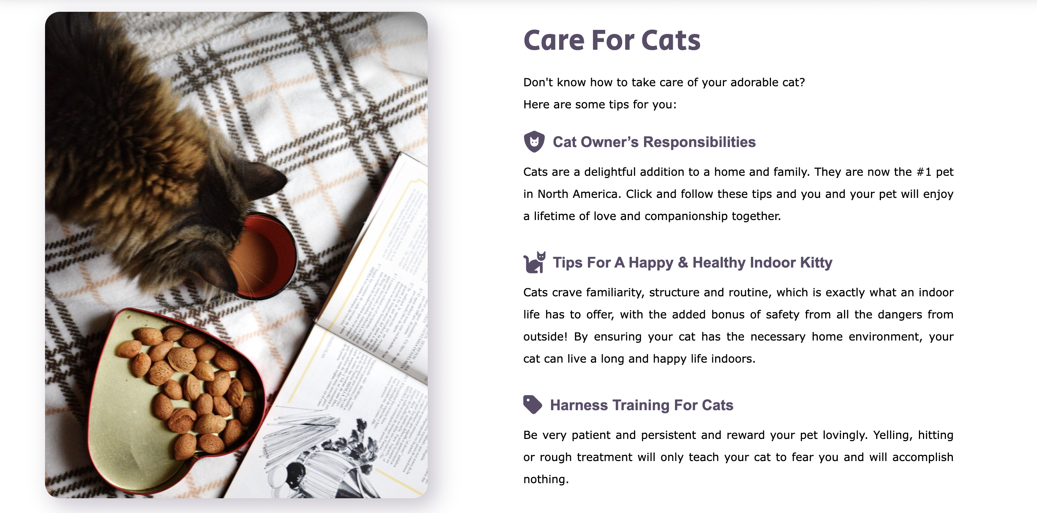 box-shadow: 10px 10px 30px 1px #5a4d6957;

**Image - Favorite:**   
 margin: 20px;  
 vertical-align: middle;  
 width: 90%;  
 box-shadow: 2px 2px 15px 0 #5a4d69a8;  
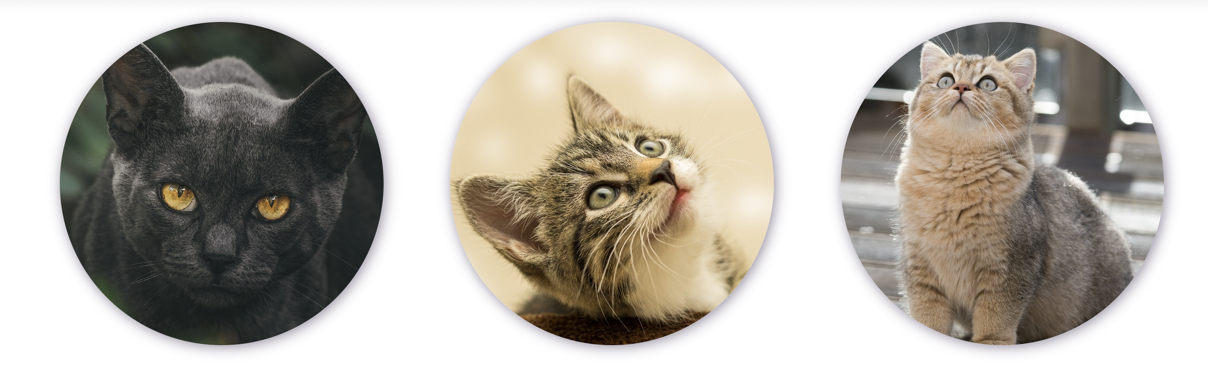 border-radius: 50%;

**Button - Vote:**  
 background: transparent;  
 border: solid 2px #f6cbd9;  
 border-radius: 50rem;  
 font-family: "Secular One", sans-serif;  
 font-size: 20px;  
 color: #5a4d69;



**Contact Box:**

background-color: #5a4d69e7;

font-family: "Secular One", sans-serif;  
 color: #f6cbd9;  
 text-align: center;

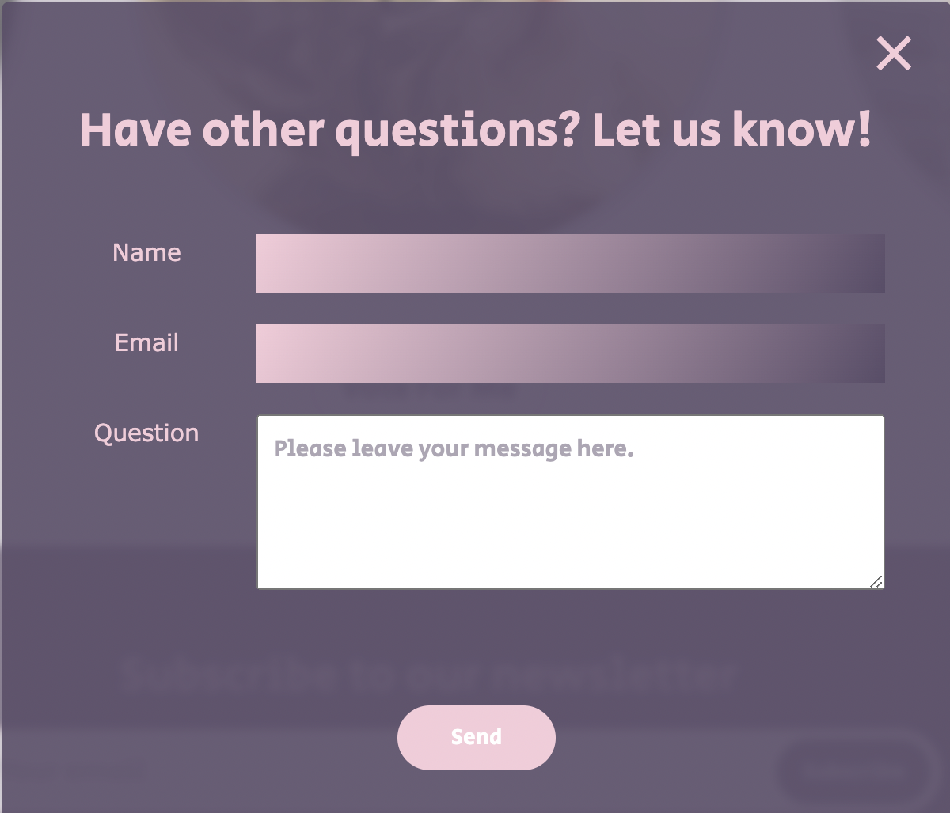 inputbox-backgroud(invalid):

linear-gradient(300deg, #5a4d69, #f6cbd9);

**Footer**

font-family: "Secular One", sans-serif;

font-size: 20px;

color: #5a4d69;

border: solid 2px #f6cbd9;   
 border-radius: 50rem;

**Main Content in Voting Page**

Background-Color: white;

Backgroud-image: A catpaw icon which is the same color as our theme color;

**Button:**

Font-size: 14px; 11px(when width of screen is less than 783px);

Color: white

Background-color: #5a4d69;

Background-color(Hover): #f6cbd9;

Align: center

**Image Div:**

Justify-content: center;

Height: 70vh, 40vh(when width of screen is less than 783px);

Width: 33vh, 24vh(when width of screen is less than 783px);

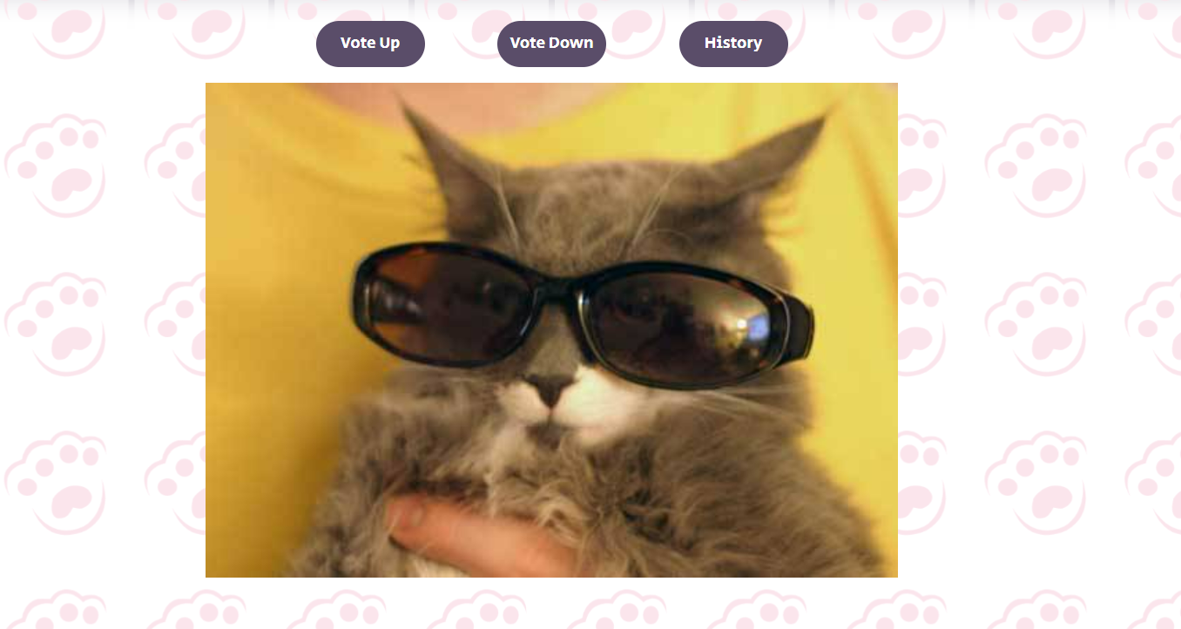

**Display page’s button:**

Width: 100px(120px when width of screen is less than 783px);

Font-size: 14px; 11px(when width of screen is less than 783px);

Color: white

Background-color: #5a4d69;

Background-color(Hover): #f6cbd9;

Align: center



**Gallery Part:**

**Outer Div:**

width: -webkit-fill-available;

height: -webkit-fill-available;

**Inner Divs:**

height: 200px;

width: 200px;

overflow: hidden;

margin: 10px 4.5vw 0 4.5vw;

position: relative;

flex-basis: 30%;

overflow: hidden;

display: inline-block;

**Border:**

border-color: #5a4d69 or #f6cbd9;

border-style: solid;

border-width: thick;

border-radius: 10px;

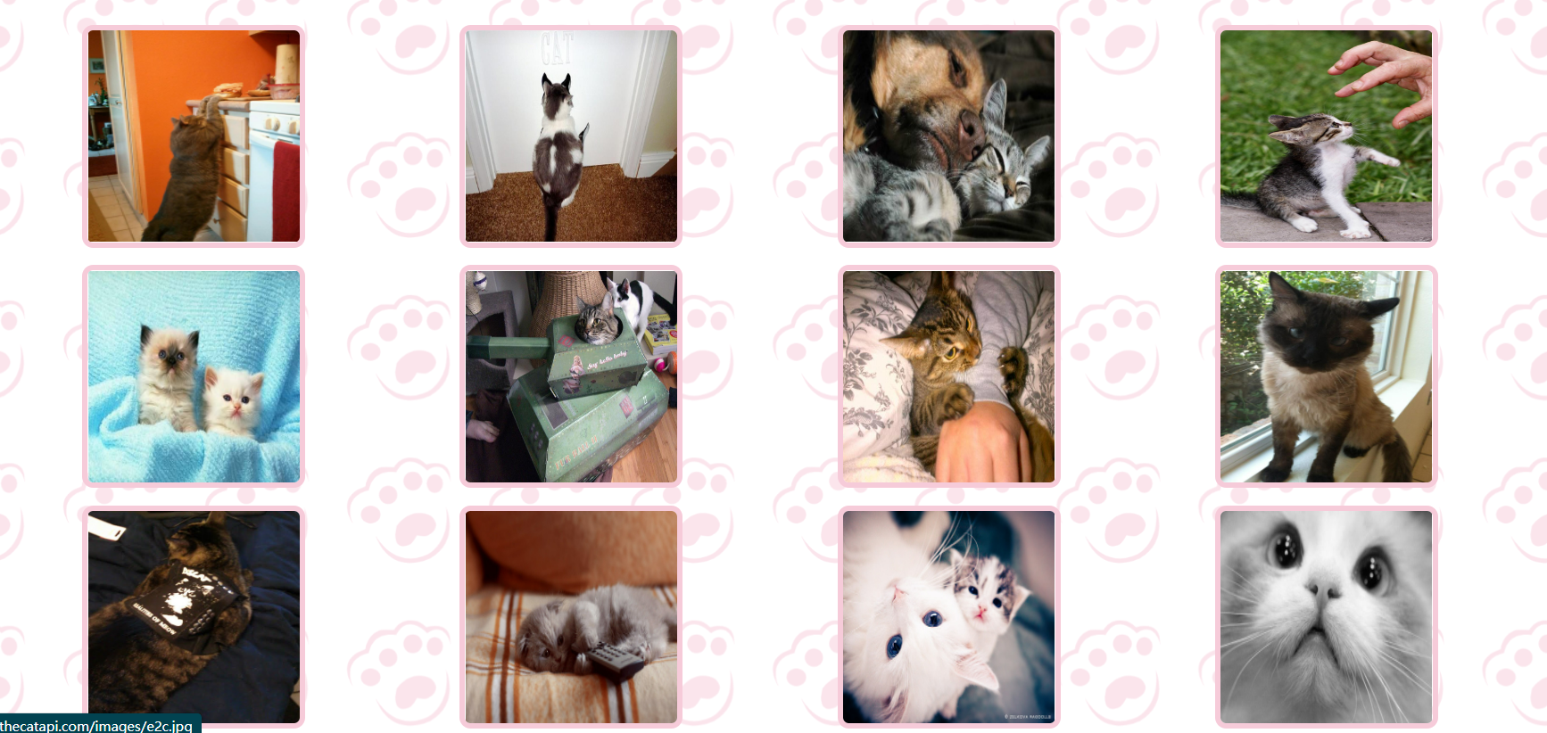

**Breed Page:**

**Search Bar:**

margin: auto;

margin-top: 10px;

width: 30%;

min-width: 450px;

height: 60px;

background-color: white;

border-radius: 50rem;

border: solid 2px #f6cbd9;

padding: 5px;

display: flex;

flex-direction: row;



**Image outer div:**

display: flex;

flex-direction: column;

align-items: center;

min-height: 532px;

**Image Divs:**

height: 50%;

object-fit: cover;

**Images inside divs:**

height: 200px;

width: 270px;

**Breed names:**

Font-size: 14pt;

**Descriptions:**

Font-size: 12pt;

Text-align: center.

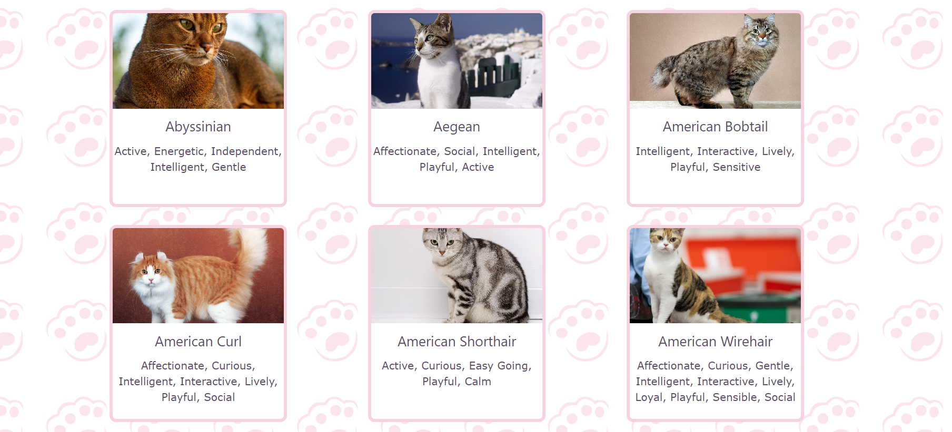

**3. User Interface Functionality Guide**

In this section we present the functionalities we built in our application and how the user can interact with them.

In general, for all pages, we designed a navigation bar and footer bar, where the user can navigate through the pages of the website. The navigation bar shows the options for index page, breeds page, care for cats page and your favorite cat or voting page, as shown in the image below.



For the footer page we have almost the same buttons as described in the navigation page: (breeds page, care for cats page, your favorite cat page; we also added a functionality called “Contact us”, where the user can send a message to the admins of the webpage with some message. They can also subscribe to the newsletter entering their email. A successful message appears in case positive.

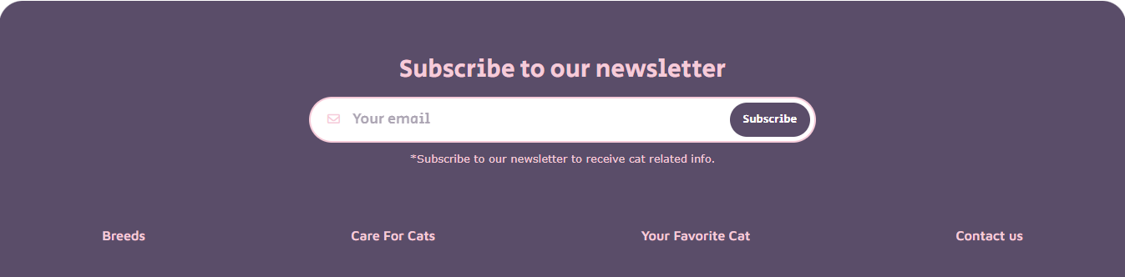

When the user clicks on the contact us button, this box below pops up in the screen, when the user has to input Name, E-mail and their Question. If successful, they receive a message confirm that the message was send.

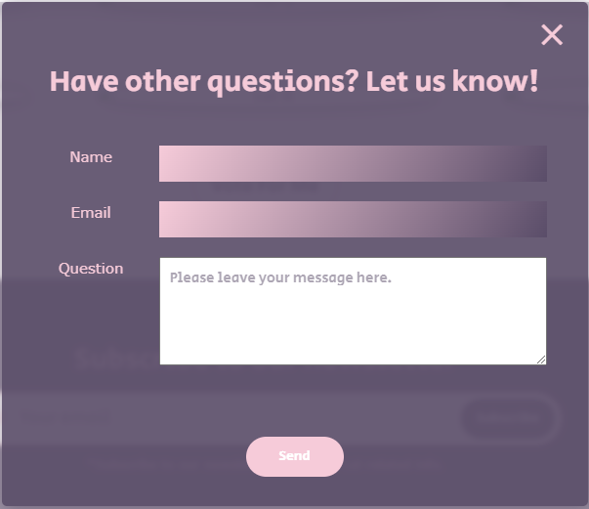

In the main content of the index page, the user can use the search bar to go directly to the breeds page with a cat name to search. He can also click in the subtitles of the care for cats section to be redirect to the care for cats page, as well as the click on the button “vote for me” will take the user to your favorite cat page.



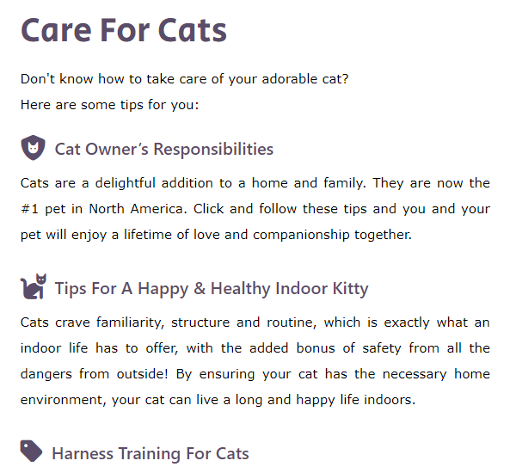



In Breeds page, there is only one functionality – besides the nav bar and footer – which is the search bar to display in the gallery only the Breeds Name included in the search of the user. The search works with the “keyup”, that means the function to return the values is executed when the user enter any value on the search bar. They do not need to click in any button to the search happen.



The Care For Cats page is a informative page, meaning that there is no functionality on the page. Its purpose is bring information about how to take care of a cat to the user.

The page “Your favorite cat” has the purpose to let the user vote up or down about the cat in the image. Every time the user access the page, it is shown a different cat randomly, hence the user can always come back to vote in new cats. This page use cookies to keep the register of the votes of the user, so they can access and see again which cat`s images they vote up or down. And when user click on the history, she/he/they can check the pics she/he/they liked/disliked and can have access to the original link of the picture and download it to her/his/their computer, and this history won’t be cleared even if the user re-open this website after closing the browser.

